Performative Publications and Recursive Publics
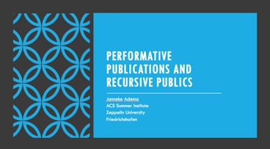
Thank you for coming to attend this lecture. So what I want to do with you today is discuss two main texts, by
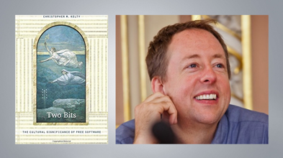
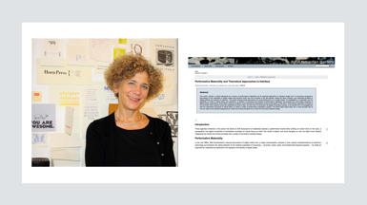
Chris Kelty and Johanna Drucker, and from there I want to delve deeper into the notion of the ‘public’ as it relates to publication, in specific academic publications. We will be focusing on two concepts in particular today: recursive publics and performative materiality. I will use these concepts as a frame to imagine a different future for scholarly communication, as part of a collective evaluation of the different modes of organisation and community that new, digital forms of communication might enable.
As part of my lecture I will be providing a few examples of publishing projects that directly relate to or find their inspiration in these concepts of recursive publics and performative materiality. I hope to end this seminar with a further discussion with all of you, focusing on how we can better engineer our own material infrastructures to better fit the ideals and practices we as cultural studies scholars would like to put forward and to both enable and stimulate the creation and existence of a public which is again able to express these ideals and practices.
I would like to start with Chris Kelty’s book Two Bits from 2008, in which he examines the cultural significance of free software. By now this book has become somewhat of a classic although it is interesting to see how some of the examples in a book on the topic of Free Software already seem so dated only ten years after its publication. I have mainly reread the introduction and Chapter 1, which I will be focusing on today, in which Kelty outlines in depth how Free Software, or the movement of “Geeks” as he calls them involved in the development of Free Software, can be seen as an example of a recursive publics. Kelty defines Free Software as follows:

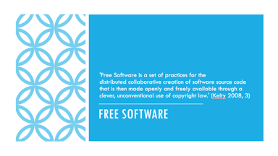

Free Software is a set of practices for the distributed collaborative creation of software source code that is then made openly and freely available through a clever, unconventional use of copyright law

The aspect of “practices” needs to be highlighted here, where, as Kelty explains, free software, as he conceptualizes it, relates to practices and to forms of life, not so much to the objects that come out of Free Software (such as the software for example). These practices range from sharing code to conceptualizing openness and collaboration, and to reimagining copyright and ownership, for example. As Kelty explains, geeks do not start with ideologies, but instead come to them through their involvement in the practices of creating Free Software and its derivatives.

Most importantly for the cultural significance of Free Software however, Kelty argues, is that it revolves around making things public; it is about creating a commons of source materials. And these practices around making things public and maintaining a commons is what is being increasingly adapted in other contexts too. In this sense it is again not so much about software, where instead Free Software exemplifies a more general reorientation of power and knowledge—and I will come back to that later.

In order to analyse and illustrate the more general cultural significance of Free Software and its consequences, Kelty introduces the concept of a “recursive public.” This relates to how Free Software should not only be perceived as a technical pursuit, as Kelty explains, but also involves the creation of a “public,” a collective that asserts itself as an independent check on other constituted forms of power. However Free Software, Kelty argues, is a public of a particular kind. It is a recursive public.

On a side note, one of the things that lets Two Bits down slightly, at least it always has done so in my experience, is that although the book literally includes dozens of attempts at defining or explaining what a recursive publics is, it remains a rather vague and opaque concept. But this is not necessarily a bad thing as it perhaps provides us some room to open out from Kelty’s attempt at a definition (which although vague, is in many ways in the manner in which Kelty describes it also rather restricted or delimited it seems). One of the clearest (but perhaps also widest) definitions is offered by Kelty at the beginning of the book:

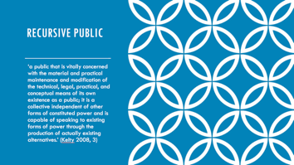

‘a public that is vitally concerned with the material and practical maintenance and modification of the technical, legal, practical, and conceptual means of its own existence as a public; it is a collective independent of other forms of constituted power and is capable of speaking to existing forms of power through the production of actually existing alternatives.’ (Kelty 2008, 3)

Kelty goes on to explain several of the concepts in this definition more in depth throughout his book, and I will come back to some of these too, including public, and maintenance and modification. Now for Kelty it is important to emphasise that a recursive public differs from interest groups, corporations and other forms of organization due to their focus on the radical technological modifiability of their own terms of existence and of the infrastructures (for example the Internet) on which they depend. As such Kelty is interested in outlining the ways in which geeks argue about, with, and through technology, by building, modifying, and maintaining the very software, networks, and legal tools within which and by which they associate with one another. As Kelty outlines:

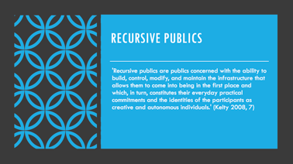

Recursive publics are publics concerned with the ability to build, control, modify, and maintain the infrastructure that allows them to come into being in the first place and which, in turn, constitutes their everyday practical commitments and the identities of the participants as creative and autonomous individuals

And it is the material aspects behind what constitutes a public, especially in our increasingly online and networked world, that Kelty wants to emphasise here. So for example, hacking and modifying software should both be conceived as forms of political action, ones that are just as important and which accompany and enable other political forms of expression such as assembly and free press. But the important thing here again, according to Kelty, is that Free Software practices are recursive, which means that they can both express and “implement” ideas about the social and moral order of society by again creating, building and maintaining infrastructures that allow ideas to circulate, and with that a public to arise.

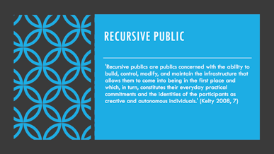

The concept of a recursive public is a way of insisting on the importance to public debate of the unruly technical materiality of a political order, not just the embodied discourse (however material) about that order.

To further explain this, communication media (be they analogue or digital) is what a public relies on in order to communicate, but a recursive public relentlessly questions the status of these media and argues that they need to be independent and public. And this is where it functions as a check on corporate and governmental powers amongst others. Modifiability, Kelty explains, is crucial here, as it doesn’t only allow access to these infrastructures and communication media, but the ability to transform and adapt them according to changing needs and uses in new contexts.

Part of this attention to how our infrastructures are set up and function, comes down to issues of governance and maintenance. For example, if we look at the creation of commons of source materials, which is what Free Software contributes to, it is not so much about the commons as a collection, it is about the philosophy of what others have coined commoning: the collective management of this collection by the public. And this relates to a further definition Kelty coins with respect to recursive publics



A recursive public is a public that is constituted by a shared concern for maintaining the means of association through which they come together as a public.

What is important here is that this maintaining and governance, as Kelty describes it, comes forth out of a shared moral imagination of the technical infrastructure, the Internet, that has allowed the Free Software community to develop and maintain this imagination and affinity in the first place.

Kelty draws amongst others on Charles Taylor’s notion of social imaginaries to position his concept of recursive publics. This shared imagination is something that is essential to the constitution of a publics, he argues, it provides order, a guide against which to make judgments and a map for changing or achieving that order. So as Kelty explains, like Taylor’s concept of the public sphere, the concept of recursive public should be similarly understood here as a kind of social imaginary. And again, for Kelty, framing recursive publics in the form of a social imaginary, serves to bypass the dichotomy between ideas and material practice. Because similar to the concept of infrastructuring in Science and Technology Studies, the creation of software, networks, and platforms troubles this distinction, as these technologies are discursive as well as having material effects in the world, they are both expressive and performative. As such, Kelty explains, a recursive publics requires a kind of imagination that includes the speaking, writing and publishing we are familiar with, as well as the making of new kinds of software infrastructures for the circulation, and modifiability of our enunciations. So next to the creation of new knowledge, Free Software also creates alternative infrastructures for circulating, maintaining and modifying this knowledge. This directly influences the political economy of our modern societies, which is why a recursive public is a useful concept to help elaborate questions around how we can reorient knowledge and power and intervene in the political fabric.

The Internet is an important infrastructure here, where the Internet is not itself a public sphere, a public, or a recursive public, Kelty explains, but it is a complex, heterogeneous infrastructure that constitutes and constrains the practices of geeks, including their ability to “become public” or to compose a common world. The Internet here functions as a heterogeneous and diverse, though singular, infrastructure of technologies and uses. Geeks’ principal mode of associating and acting is through the medium of the Internet.

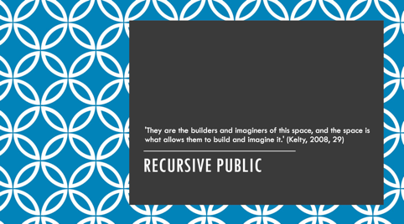

As Kelty emphasises, they are the builders and imaginers of this space, and the space is what allows them to build and imagine it.

In this sense, geeks use the Internet, and technology more in specific as a kind of argument, to argue for a specific kind of order. As I earlier explained, they argue about technology but they also argue through it and with it. The recursive public, when we bring it back to publishing for example, is thus not only the book and the discourse around the book, even if we would include the various digital media that could make up the book these days. It includes the technical structure of the Internet as well, in other words, which platforms and technologies we should use to produce and distribute books. It is about protocols and standards, applications and software, about the licenses and regulations that govern these as well as the book. Recursive publics in this sense are distinctive because they include not only the discourses of a public, but the ability to make, maintain, and manipulate the infrastructures of those discourses as well.
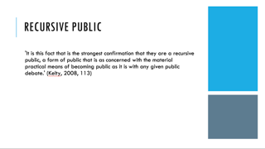
In this respect recursive publics are not restricted to only having access to the activities of speaking, writing, arguing and protesting, they have the ability to build, maintain and modify themselves as part of their engagement with the Internet, which is the kind of environment they can inhibit and transform, providing them with as Kelty states, a platform through which they can both associate and create, and a platform that is independent and autonomous of conventional state and corporate forms of power.

At this point I would like to move to Johanna Drucker’s text, but I just wanted to ask if there are any questions about Kelty’s text or if anything is unclear?

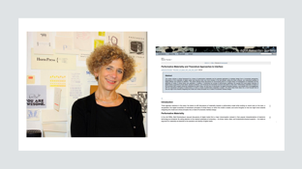
So in her article in Digital Humanities Quarterly from 2013, Johanna Drucker discusses the concept of performative materiality. As a concept it relates to the notion of posthumanist performativity, which has been developed in theories of new materialism, most prominently in the work of Karen Barad. Drucker, in her version of this concept, focuses specifically on publishing, which is why I wanted to discuss her article here today, and it also explores the roots of this concept in a range of fields and approaches, including media archaeology (through an exploration of Matthew Kirschenbaum’s work), interface theory, critical code studies and approaches to forensic and distributed materiality, and how they relate to critical digital humanities and media studies.

I want to focus mainly on her concept of performative materiality though. Drucker develops this concepts to battle a similar pressing issue Kelty also aimed to break down, namely how the foundation of the digital, or of digital technology, is often presumed to be immaterial, ignoring the physical and material elements of digital code. What these approaches around the immaterial digital fail to comprehend however, is that their descriptions are grounded in ontology, rather than in performance, as Drucker explains. In other words, they try to find the identity of digital media in properties and capacities, in what media are rather than what they do. So Drucker, instead of necessarily breaking down this binary distinction, with her concept of performative materiality she wants to extend rather than replace this understanding. As she defines Performative Materiality:

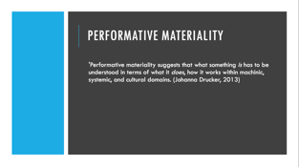

Performative materiality suggests that what something is has to be understood in terms of what it does, how it works within machinic, systemic, and cultural domains.

In her exploration of what sets this concept apart from similar concepts, Drucker takes on a genealogical approach, similar to what we are used to from media archaeology, explaining where the thinking around this concept arises and where it differs from other related concepts. So for one she moves beyond the notion of distributed materiality, which describes the co-depended, relational aspects of digital networks and systems. These networks and systems are governed by their particular material design, invoking one of the constraints or thresholds that Kelty also described in relation to Free Software. As Drucker points out distributed materiality edges towards an events-based model, which is what she wants to emphasise, even though it is still focused on separate entities and their relationality. For her concept of performative materiality however, Drucker takes a wider approach:

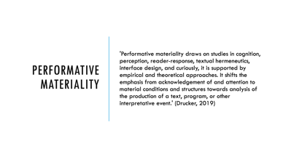

Performative materiality draws on studies in cognition, perception, reader-response, textual hermeneutics, interface design, and curiously, it is supported by empirical and theoretical approaches. It shifts the emphasis from acknowledgement of and attention to material conditions and structures towards analysis of the production of a text, program, or other interpretative event.

What sets Drucker’s approach apart, and what she wants to critique with this concept of performative materiality is notions of naïve, literal materiality. She wants to move away from notions of media specificity, which we encounter in many analyses of digital artefacts within literary and critical studies, and which is the expression of a tendency to assign intrinsic and inherent values to material properties. Again, as Drucker explains, this reflects a wider shift from what something is towards how something works, which of necessity then also includes, as Drucker explains, the further lifecycle of production, control, labour and environmental issues a material artefact is embedded in, where in this case its materiality does not stand alone but should be read as a snapshot moment within continuous interdependent systems. And this is also why Drucker wants to move away from a notion of entities to a notion of events as part of her concept of performative materiality:

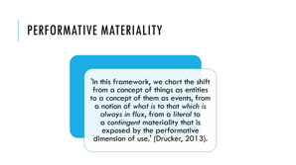

In this framework, we chart the shift from a concept of things as entities to a concept of them as events, from a notion of what is to that which is always in flux, from a literal to a contingent materiality that is exposed by the performative dimension of use.

What Drucker wants to emphasise here is that media objects are not self-identical, and they are not observer-independent, instead in the performative approaches she supports, objects are the effects of dynamic relations between an objects’ characteristics and encounters with interpretative processes. This is where the performative dimensions of an object’s properties, are actualized in contingent encounters, relations and dependencies, so in other words, when we view or read a media object, our interpretation of that object becomes part of that object, it shapes it—think about hypertext for example as a good example of this, although it covers all forms of media and interpretative interactions with media. So what is important to Drucker is that we understand the production of a work, be it a media or literary object, as an interpretative event, as something which finds its meaning through its execution, in the way its function is extended through events of encounter. So where formally a work can be seen as a set of encoded instructions of how to read, view or experience it, in a performative approach, as Drucker explains, the reader is part of the execution of the work through an encounter. In this sense she highlights,

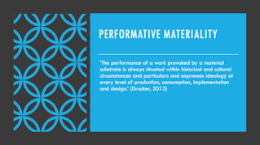

‘The performance of a work provoked by a material substrate is always situated within historical and cultural circumstances and particulars and expresses ideology at every level of production, consumption, implementation and design.’

And this is again where this notion of performative materiality has political relevance, similar to Kelty’s notion of a how a recursive publics is dependent on elements of modification to institute its own existence. In a similar vain, Drucker asks, how we can work towards a situation where the fact that our interpretation of or interaction with media objects, shapes both these objects and their interpretation, will have a direct influence on the way we design these objects? So we can see a kind of recursive feedback loop at play here too, where as Drucker argues, the elements of design need to take into considerations how the elements of design influence both the object and the designer. Hence the way our media currently function has a direct influence on our interpretation of and interaction with them, which asks questions about how we can and should design our media objects and events, differently. And this is where humanities theory comes into play, as Drucker argues

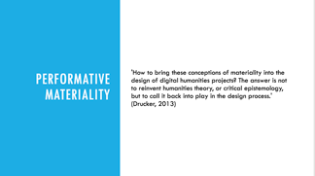

How to bring these conceptions of materiality into the design of digital humanities projects? The answer is not to reinvent humanities theory, or critical epistemology, but to call it back into play in the design process

Ontologies, definitions and descriptions are ideological through and through, they are not objective descriptions of reality, of a media’s affordance, they, as Drucker outlines ‘involve, interpretative acts that enact their view of knowledge, reality, and experience and give it form.’ In this sense it is a political act to focus less on the product or the finished form and more on the acts of producing these objects and how they support certain interpretations instead of others.

At this point I would like to move from the concept of performative materiality to a particular application of this approach, although one that again differs from Drucker’s formulation, in the form of performative publications, and this is where I will also focus on some of my own theoretical and practice-based work on this subject matter. Following on from what we have learned from Kelty and Drucker, the design of our infrastructures of communication is an inherently political act, and one which helps us in constituting ourselves as a recursive or self-reflexive public, something that, as I would argue, is inherent to the cultural studies project too. So critically exploring the forms of our own material means of communication as academics, which take place through articles and books mainly, becomes a political act and makes it necessary for us to better control their means of production. So this is something which I have explored through the concept of performative publications.

A performative publication wants to explore how we can bring together and align more closely the material form of a publication with its content.

The term performative publication was coined by Christopher P. Long, who defines it as a publication in which ‘the mode of publication performs one of the central ideas the text itself seeks to articulate and explore’ (Long 2013). Performative publications focus on how the mode in which we produce, disseminate and consume text, influences the content and meaning of the text, or the way we interpret it. Here the accent lies more on the material agency of publications, not merely investigating their own materiality, but actively performing it. So again, following Drucker, the focus is on having more in depth discussions about the way we do research. How can we ensure that, throughout the research process, we focus on the medial forms, formats and graphic spaces in and through which we communicate and perform scholarship, as well as on the discourses, agencies and institutions that shape and determine our scholarly practices? This ‘contextual’ discussion, focusing on the materiality of our (textual) scholarship and its material modes of production, is and should not in any way be separate from a discussion on the content of our work.

‘performative publishing’ finds its genealogy in and correlates with ideas such as ‘performative materiality’ (Drucker), ‘technotext’ (Hayles), and ‘liberature’ (Fajfer), alongside other projects and practices. What then are the ethical and political challenges towards academic publishing these kinds of concepts and practices pose?

So going back to Chris Long’s work on this subject matter, For Long performative publications are directly connected to the idea of practice, where following the concept of performativity, he argues that ideas should be put to practice, where practice can further inform and enrich one’s ideas again.

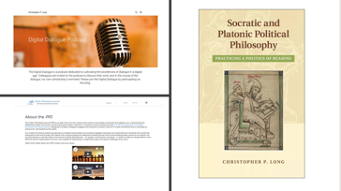

Long applies these values directly to several of his own performative projects. In his book The Socratic and Platonic Politics: Practicing a Politics of Reading, he shows how Socratic philosophy and Platonic writing was designed to cultivate dialogue and community. By digitally enhancing his publication, Long explores how writing and reading can promote community in a digital context, in specific a community of collaborative readers. As Long argues: ‘If, however, the book is not to be a mere abstract academic exercise, it will need to be published in a way that performs and enables the politics of collaborative reading for which it argues’ (Long 2012). A further extension of this project is a podcast series titled Digital Dialogue which aims to cultivate dialogue in a digital age by engaging other scholars in open conversation online. Long is also involved in the Public Philosophy Journal project, which is specifically set up to crawl the web to find diverse positions on various philosophical subjects and to bring these together in a collaborative writing setting. As Long explains: ‘The PPJ is designed to crawl the web, listening for conversations in which philosophical ideas and approaches are brought to bear on a wide variety of issues of public concern. Once these conversations are curated and a select number chosen for further development, we will invite participants into a space of collaborative writing so they can work their ideas up into a more fully formulated scholarly article or digital artifact’ (Long 2013).

Long's publications are exemplary for bringing into practice a specific ethics and politics making use of the affordances of the digital medium to help embody more fully what publics, practice, dialogue, community, writing, reading and collaboration can and could mean in an online environment. In this sense his work explores what the possibilities of such a politics could be in a digital context. At the same time of course, the digital influences and affects what these concepts are and could be and therefore can be seen as an active agent in their unfolding.

Yet in what sense can a performance of Socratic and Platonic ethics and politics, and related ideas of the good life in a digital context, leave space open for a rethinking of what politics is based on our performance of scholarship online? As a system of thought how does it delimit political development? As Gary Hall has argued: ‘Instead of developing new, singular, or at least specific theories of the politics of new media, critics have for the most part tended to understand digital politics in terms of already decided and legitimated theories and ideas’ (Hall, 2008, 149). For Hall then, following Mark Poster, cyberdemocracy emerges as a potential space for new, ‘unthought’ forms of democracy, where ‘in order to understand the politics of the Internet we need to remain open to the possibility of a form of politics that is “something other than democracy” as we can currently conceive it’ (Hall 2008, 179–180).

How can we stimulate performative intra-action in this sense, where performative publications are not just passive embodiments of previously defined concepts and contents, but instead reciprocally shape and affect these? How can we ensure the experimental elements of recursivity Kelty talks about? How can we ensure that practice seeps back into our theoretical considerations (while emphasising their ongoing entanglement)? In the context of Long's work, how does our current digital performance of Platonic and Socratic ethics and politics alter our understanding of as well as the praxis of these philosophical practices?

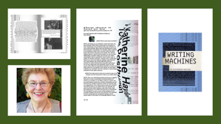

As a term, performative publications have a lot in common with Katherine Hayles’s concept ‘technotexts’. In her book Writing Machines (itself a technotext, beautifully designed by Anne Burdick in a hybrid print and ‘webtake’ version) Hayles introduces the term technotext as an relative and alternative to concepts such as hypertext and cybertext. She defines a technotext as something that comes about ‘when a literary work interrogates the inscription technology that produces it’ and elsewhere as ‘a book that embodies its own critical concepts’.

Yet there exists a difference in focus and emphasis between what Hayles defines as technotexts and what I theorise as performative publications. In the latter the accent lies more on the material agency of publications, not merely investigating or interrogating their own mediality or materiality, but actively enacting or performing it. How does the term ‘technotext’ in this sense relate to the emphasis in a lot of current theory on what texts do and not just what they mean or signify, or even embody? In this respect it is useful to go back to Johanna Drucker’s conceptualisation of performative materiality, where she states that ‘performative materiality is based on the conviction that a system should be understood by what it does, not only how it is structured’ (Drucker 2013). Hayles does however also focus on this aspect of ‘doing’ when she states that what technotexts do, is ‘bring into view the machinery that gives their verbal constructions physical reality’ (Hayles 2002, 26). However, here again one could argue that performative publications move beyond a ‘bringing into view’ or a ‘reflecting on’ their own mediality, where they are actively involved in performing it or performatively disrupting or intervening in it.

In this respect one could argue that technotexts are focused more on the ontological dimension of literature than on its actual performance. Again, as Drucker also argues, as a concept performative materiality should be seen as an extended dimension of materiality, not as an alternative or a replacement, and in this sense performative publications can be seen as a further extension of what Hayles explores with her concept of technotexts. As Drucker states, ‘performative materiality suggests that what something is has to be understood in terms of what it does, how it works within machinic, systemic, and cultural domains’ (Drucker 2013). In this sense it goes beyond reflection and ‘shifts the emphasis from acknowledgement of and attention to material conditions and structures towards analysis of the production of a text, program, or other interpretative event’ (Drucker 2013).

Technotexts as a term also seem constricted to ‘texts’ to some extend and to their technologies of inscription, where, as I would argue, performative publications encompass a broader ecology of materiality, taking into consideration not only the technologies that make up a text or a work but also the discourses, authorial intentions, systems and forms of material production that a publication is entangled with and performs. In this respect performative publications ‘interrogate’ and intra-act with what produces them in a broader sense, going beyond technology to include ideas of the book, originality, copyright, publishing models, the poethics of scholarship etc.

If performative publications are the material expressions or incarnations of specific research projects and processes, entangled with them are various other agencies of production and constraint (i.e. technological, authorial, cultural and discursive agencies, to name just a few). What I want to argue is that performative publications as a specific subset of publications actively interrogate how to align more closely the material form of a publication with its content (in other words, where all publications are performative—i.e. they are knowledge shaping, active agents involved in knowledge production—not all publications are 'performative publications', in the sense that they actively interrogate or experiment with this relation between content and materiality —similar to artist books). Yet in addition to this there is also an openness towards the ongoing interaction between materiality and content which includes entanglements with other agencies, and material forms of constraint and possibility.

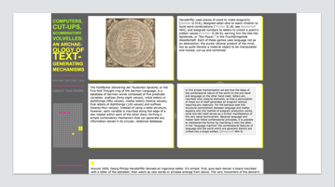

One example of what I would claim is not only a technotext but also (or in addition to that) a performative publications is Whitney Trettien's Computers, Cut-ups, and Combinatory Volvelles: An Archaeology of Text-generating Mechanisms (2009). Trettien’s thesis presents an archeology of text-generating mechanisms, exploring writing as ars combinatoria—as a material, combinatory practice—examining a wide array of forms from volvelles to cut-ups and digital poetry. Yet Trettien presents not a simple linear and narrative history; her archaeology is itself designed as an online combinatory text-generating mechanism. Even more, Trettien's work not only reflects or interrogates its subject or contents by performing its ideas materially: in addition to this it also, simultaneously, intervenes into this debate in a performative way (both conceptually and practically), defamiliarising the, as Trettien states, presumed natural ‘institutional conventions of scholarly reading, writing and publication’ (2009). Her digital mechanism demands that the reader participate in the construction and performance of her work, for example. As Trettien argues: ‘by both presenting and enacting the very mechanisms I theorize, I hope to put a neglected past in conversation with our present while still waving "goodbye to much that is familiar"’ (2009).

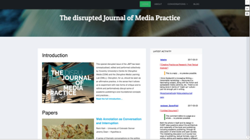

A second project I want to discuss is a journal special edition I have been involved in, which we have edited collaboratively with our colleagues from the Disruptive Media Learning Lab: The disrupted Journal of Media Practice. For this special issue we wanted to experiment with how media practice, in rethinking research as practice, could also be involved in disrupting the way we mediate this research through various formal and informal scholarly forms, including the academic journal. What could a ‘journal of media practice’ be that moves beyond a collection of standard single-authored linear 8000-word journal articles, of practitioners writing mainly text-based articles about their practice or projects, instead of thinking how they could make publishing part of their practice, or part of the performance of their practice. How then is media practice disruptive of and re-performing the way we do scholarly communication? We envisioned the journal itself as an output of creative conception and production, which showcases the various forms practice-based research can (potentially) take, whilst at the same time emphasising that this research can be of equal quality as well as being just as rigorously reviewed as more traditional text-based articles.
The way we conceptualised this special issue is that it was structured around a series of curated conversations to emphasise the evolving and collaborative nature of the research. The articles around which these conversations have centered openly evolved from ‘drafts’ to ‘final versions’ and beyond on a custom-designed platform, as well as on participants’ own websites and servers or on external multimedia platforms. Our platform was built based on the authors’ requirements, enabling a range of options for multimodal and processual content. The submissions around which our conversations were centered are multimodal, text-based and/or hybrid; both processual and collaborative.
We had a podcast about podcasting,
a Scalar publication about practice-based research methods,
and an article written in the margins of the project it described. And this article includes some of the texts I have just read around performative publications.
The conversations were enabled and structured with the help of the hypothes.is annotation plugin, which allowed comments directly in the margins of the projects themselves. Using custom-designed tags (for example #disruptedjournal) we were able to set up a live-feed of the comments as they developed around the content both on and off platform, providing a timeline of the combined conversations on the platform around a certain topic. This process lasted a few months, after which we arranged a formal open peer review process, again via hypothes.is, for those submissions of which their authors felt they were ready to be published. Some of the contributors on the platform opted out of this part of the process, for example because they felt their content needed further development. In practice many reviewers and reviewees also had various offline conversations via email or other forms of communication. One of the reviews, for the contribution submitted by the Cinematologists, which was in the form of a podcast, was similarly recorded as a podcast review and was subsequently mixed into the Cinematologists’ final submission for this special issue.
Next to the version of this special issue that is available on the platform, the journal editors and T&F insisted we also create a fixed version of record, both in print and in a hyperlinked PDF, available on the T&F website. Where the ‘platform’ version of this special issue had relatively few boundaries concerning length, form and development of the submissions, the ‘print’ version forced us to rethink what a disrupted Journal of Media Practice might be, given the constraints of the print medium as well as the publisher’s guidelines. We custom-designed the print edition, together with a designer and our authors, creatively responding to the specific affordances of their projects, where the authors were asked to think about how they would like to see their contributions translated in a print environment. This did lead to some interesting decisions (for example, in the print and PDF version, the podcast submission was represented by a QR code which linked back to the online version
and for the publication which was written in the margins in a nested way, the designer reproduced this layered aspect using markers and difference in font sizes.

Although the print or T&F PDF is the ‘version of record’, this special issue encompasses all these online and offline versions. With this focus on the processual nature of the research we wanted to challenge the focus on the publication as a fixed and finalized object and commodity, which, especially in the context of practice-based research, does not reflect the research process. Through this experiment in editing, curating, designing and perhaps most importantly, community-building, we wanted to create an environment which both supported and stimulated the various forms in which media practice can be published, whilst collaboratively developing both the platform, the content and projects.



To conclude I would like to return to what I prompted us to think about at the beginning of my lecture -- and I also want to shortly connect back to the two short articles on the reading list by Eileen Joy at this point -- concerning how we ourselves can become more involved in the design of the infrastructures and materialities that shape and determine how we communicate as scholars, and how through this we can encourage recursive or self-reflexive publics to emerge, a publics which in this context moves beyond our still rather isolated community of scholars. And this comes back to two of the main infrastructure we use to communicate our ideas and ideologies: the public university and the academic publication.

Eileen Joy, who runs the not-for-profit open access publisher punctum books, addresses these institutions through the lense of cultural authority, and calls for the humanities to move beyond this institutionalized cultural authority if it wants to innovate, to create the, as she calls it a ‘more richly tapestried and noisy public commons’. For Joy then, it is important that we start to move away from a model of a hierarchical university knowledge trickling down to the masses. If we want a public commons to arise, one that is more open, diverse and democratic, in an agonistic way, the university needs to be more open too to the ideas of those that stand outside of it, what Joy calls its ‘supposed non- and para- and anti-institutional Others.’ And this revolt needs to happen every time cultural authority rears its head in new contexts or situations.

And publishing is an opportune place to start questioning and disrupting this cultural authority

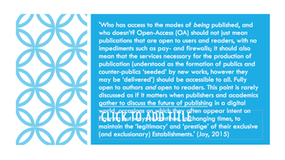

Open-Access (OA) should not just mean publications that are open to users and readers, with no impediments such as pay- and firewalls; it should also mean that the services necessary for the production of publication (understood as the formation of publics and counter-publics ‘seeded’ by new works, however they may be ‘delivered’ — more on which below) should be accessible to all. Fully open to authors and open to readers. This point is rarely discussed as if it matters when publishers and academics gather to discuss the future of publishing in a digital world, occasions on which they often appear intent on figuring out ways to continue, in changing times, to maintain the ‘legitimacy’ and ‘prestige’ of their exclusive (and exclusionary) Establishments.

What is important here then for Joy, is that publishing does not just revolve around the making public of content, but instead she emphaises that publishing is a process, it is about creating the tools, and infrastructures, and platforms for publications to be produced and disseminated in addition to the publications themselves, around which certain communities might coalesce, and be sustained. These spaces then could function as counterpublics, from where we can build new avenues of access for novel (and counter-institutional) modes of thought and writing. Joy argues that seemingly illegitmate presses, such as punctum books, can build shelters for illegitmate publics to arise, publics that create unruly ideas that questions the institutions of authority in academia. So my question to all of you know is: how can we as cultural studies scholars create similar shelters for unruly publics and unruly ideas to arise? Thank you.

